**YOUR DONATION DOUBLED!**

Encourage Autistic children, youth and adults by making a special year-end gift. Give today to help children, youth and families involved in the child welfare system through urgent basic needs, mental health services, Rent assistance and much more. Every dollar you give today will be MATCHED by our generous donor the Garden of Eden Auatism Retreat center up to a total of $50,000*.

If you’d like to receive a 2023 tax-deductible receipt, please donate before 11:59PM on December 31, 2023.

*(Put the text on this picture. to the above our own picture) Customize to our company*

2X your impact

This Holidays season, help add value to families with Autistic children and youth.

(Sample )

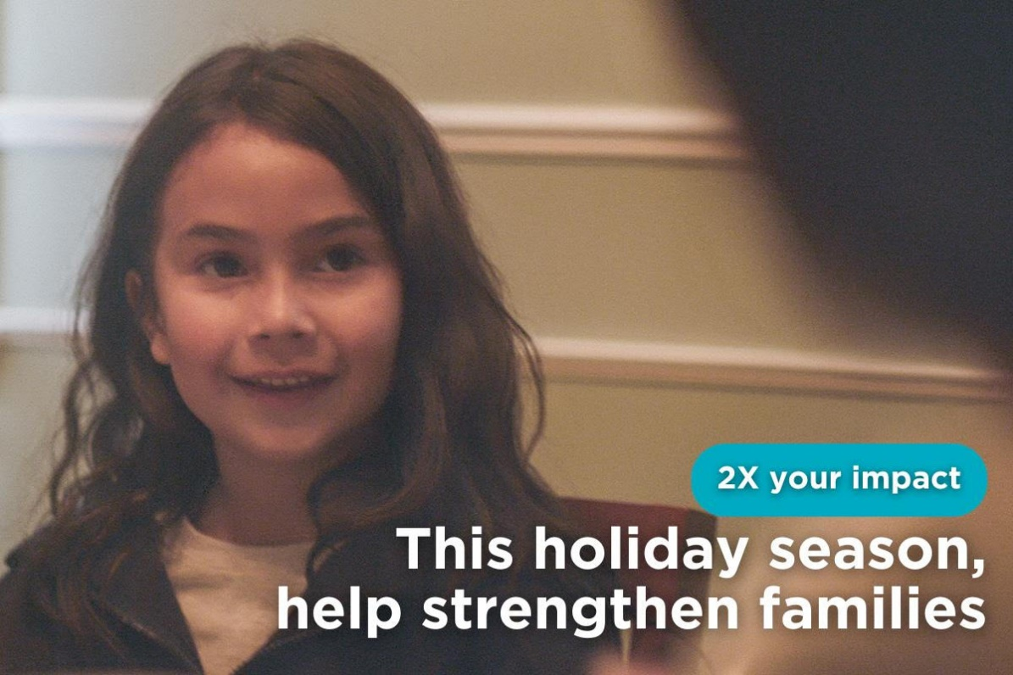

One-time donations made as part of the GOEARC Holiday campaign (Year-End) will be matched by the Garden of Eden Autism Retreat Center until $50,000 CAD in donations are received.

Your privacy is important to us. Garden of Eden Autism retreat center Canada will keep your personal data secure. For more information, please see our Privacy Policy

Charitable Registration Number: 739994721RC0001

©2023 Garden of Eden autism retreat center Canada

Please check this link and do it as it is ecommerce section

<https://give.cafdn.org/page/135773/donate/1?locale=en-CA>